Southwest University
School of Computer and Information Science

Program: Computer Science and Technology
Couse Title: Principle of Programming
Chapter Title: Files and exceptions
Unit No: 06
Assignment No.: 02

Issue Date: 2021-11-25

Submission Deadline: 2021-12-2

Assessor/Tutor: Ya Li

Student Name: Yi Cheng

Student No.: 222021321102110

Grade：

NOTES TO STUDENTS
- Check carefully the submission date and the instructions given with the assignment. Late assignments will not be accepted.
- If you are unable to hand in your assignment on time and have valid reasons such as illness, you may apply (in writing) for an extension.
- If you are caught plagiarizing, you could have your grade reduced to zero, or at worst, you could be excluded from the course.
- Your submission document should include screen shots of the Python IDLE showing your code and the output results of running your code.
- Complete your assignment in Word document and submit it to FTP server
- Your file name should start with your Reg. No, and then include your name, and assignment NO. for example “222012321062259_李丹_assignment1.docx”. Remember to link different fields together using the underscore character (_).

Formatting Concerns
#1: You should have a header that explains the program
#2: There should be a space between the prompt and the place where you type in the value.
#3: Your work should be formatted nicely as in the sample output.

STUDENT’S DECLARATION:

I confirm that this is all my own work.

Student Signature:

Assignment Description
Scenario and Tasks：

1. practice on exceptions
Write a program that prompts for three numbers. Divide the first number by the second number and add that result to the third number. Using exceptions check for the following errors: ValueError, and ZeroDivisionError.

Solution:

Code:
nums = [0, 0, 0] # Use listing to make your code thiner
while True:
for i in range(3): # Check each time whether the input is valid
while True:
nums[i] = input('Please input the number %s: ' % (i+1))
try:
nums[i] = int(nums[i]) # Conversions are preferred if they can be converted to the int type
except ValueError:
try:
nums[i] = float(nums[i]) # Try the conversion bit float type again, and if you can't, report the error and prompt for re-entering
except ValueError:
print('The number you input is valid. Please try again.')
continue
break
try:
nums[2] += nums[0] / nums[1]
except ZeroDivisionError:
print("Some numbers can't be calculated. Please check your numbers.")
continue # If you encounter ZeroDivisionError, you are asked to re-enter the number
for i in range(3):
print('The number %s: %s' % (i+1, nums[i]))
break # Print the output and end the run if possible

Screen Capture of The Result:
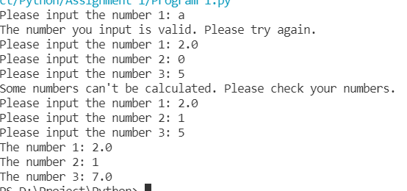

2. File reading & Writing

Create a test file with a single sentence of 20 words(one line). Read the file, then insert carriage-return characters (\n) and write the test to a new text file that will be composed of four lines of five words.

Solution:

Code:

import os
from posixpath import split

path = os.path.dirname(__file__) # Confirm the absolute path and avoid relative path errors

source = open(os.path.join(path, 'source.txt'), 'r')
processed = open(os.path.join(path, 'processed.txt'), 'w')

content = source.read().lower().split()
for i in range(20):
processed.write(content[i].strip(',.'))

# Wrap a line if it is full of 5, otherwise spaces will be spaced
processed.write('\n') if i % 5 == 4 else processed.write(' ')

Screen Capture of The Result:
